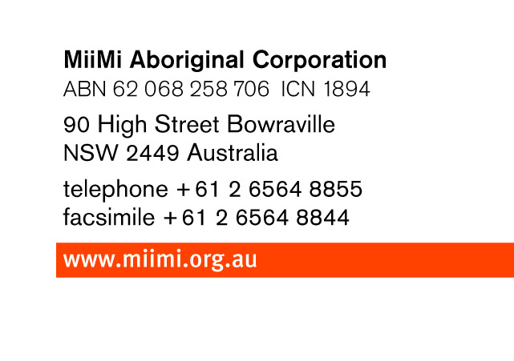

Section 1: To be completed by the applicant.
Details: Mr Mrs Miss Ms
Family or Last name: _____________________________________________________________

Given Name(s): ____________________________________ Date of Birth ______/______/______

Signature: ________________________________ Date: ______/______/______

Section 2: To be completed by the applicant
A. GRANDPARENTS DETAILS:
Grandfathers Surname:_____________________ Grandfathers First Name:_________________
Date of Birth: _______________ Place of Birth:__________________________

Grandmothers Maiden Name:________________ Grandmothers First Name:________________
Date of Birth: _______________ Place of Birth:___________________________

B. PARENTS DETAILS:
Fathers Surname:_________________________ Fathers First Name:______________________
Date of Birth: _______________ Place of Birth:___________________________

Mothers Maiden Name:_____________________ Mothers First Name:_____________________
Date of Birth: _______________ Place of Birth:___________________________

MiiMi Aboriginal Corporation reserves the rights to deny or allow Confirmation of Aboriginality

